**CHBI 422/522**

**HW1**

**Due Date: March 10, 2022 at 23:59**

1. Consider two rigid helices as shown below. Each helix can be considered as a dipole with two interaction sites: one end positively charged (+1), the other end negatively charged (-1). Suppose the non-bonded sites interact with a potential of $E_{12}=\frac{q_{1}q_{2}}{d}$ where $d$ is the distance between the centers of helices.

What would be the optimal configuration of the two helices? Assume there are point charges only at the ends.

Hint: Consider two configurations; 1) both positive ends are facing each other, 2) one positive end faces the negative end.

Write the total energy between charges and see which one is more favorable. Assume the length of the helix is .

1. Calculate the backbone length of an alpha-helix with 4 turns.

1. Where would you expect to find the below helices in a cell? In cytosol or in the membrane or somewhere else? Draw the spiral organization and look from the top view.

|  |  |  |  |  |  |  |  |  |  |  |
| --- | --- | --- | --- | --- | --- | --- | --- | --- | --- | --- |
| Ile | Lys | Phe | Val | Ala | Ala | Leu | Gly | Leu | Met |  |
| Leu | Gln | Lys | Gly | Phe | Arg | Ile | Ile | Glu | Thr | Gly |
| Glu | Lys | Asp | Val | Arg | Ala | Ser | Lys | Lys | Lys |  |

1. Below is a single letter amino acid sequence of a protein (KRas4B).

>6VC8_1|Chains A, B, C|GTPase KRas|Homo sapiens (9606)

GMTEYKLVVV GAGGVGKSAL TIQLIQNHFV DEYDPTIEDS YRKQVVIDGE TCLLDILDTA GQEEYSAMRD QYMRTGEGFL CVFAINNTKS FEDIHHYREQ IKRVKDSEDV PMVLVGNKCD LPSRTVDTKQ AQDLARSYGI PFIETSAKTR QGVDDAFYTL VREIRKHKEK

Find a protein tool/server that predicts the actual secondary structure of the protein. Compare with the actual secondary structural elements. Which features does the tool use? The actual secondary structures can be found at:

HELIX 1 AA1 GLY A 15 ASN A 26 1 12

HELIX 2 AA2 TYR A 71 GLY A 75 1 5

HELIX 3 AA3 ASN A 86 ASP A 105 1 20

HELIX 4 AA4 ASP A 126 GLY A 138 1 13

HELIX 5 AA5 GLY A 151 GLU A 168 1 18

SHEET 1 AA1 6 ASP A 38 ILE A 46 0

SHEET 2 AA1 6 GLU A 49 ASP A 57 -1 O ILE A 55 N TYR A 40

SHEET 3 AA1 6 THR A 2 GLY A 10 1 N TYR A 4 O ASP A 54

SHEET 4 AA1 6 GLY A 77 ALA A 83 1 O LEU A 79 N VAL A 9

SHEET 5 AA1 6 MET A 111 ASN A 116 1 O ASN A 116 N PHE A 82

Calculate the accuracy of your prediction for the first 50 amino acids. You need to know true positive, false positive etc… The formula is given here:

Accuracy = (TP+ TN)/(TP+ TN+ FP+ FN)



The tool I used was [RaptorX](http://raptorx.uchicago.edu/StructurePropertyPred/predict/), this is a web server tool that utilizes an in-house deep learning framework (Deep Convolutional Neural Fields), since this is a DL method, it doesn’t utilize explicit features.

Ref: <https://academic.oup.com/nar/article/44/W1/W430/2499323?login=false>

Accuracy:

TN (number of true coils): 18

FP: 0

FN: 6

TP (true hits either if sheet or helix): 7 + 10 + 7 + 2 = 26

Accuracy = (18 + 26) / 50 = 88%

1. List five of the most observed domains in proteins. List five motifs in proteins and insert a picture of each from the internet with proper references.

*Five of the most common motifs are:*

1 -Helix-loop-helix:

.

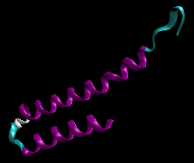[1]

2 - 4-helix bundle:

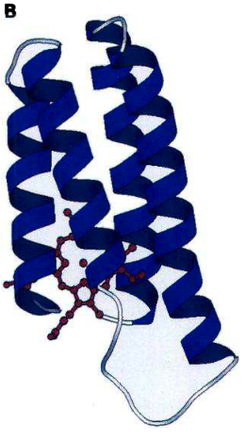[2]

3 - Hairpin:

[3]

4 - Greek key motif

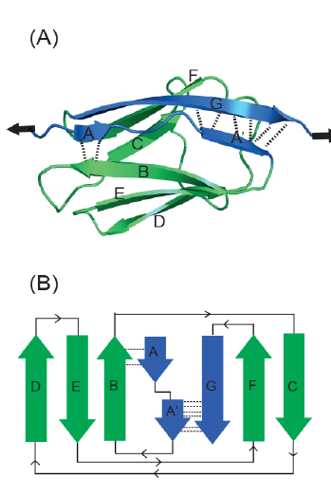[4]

5 - Parallel beta helix

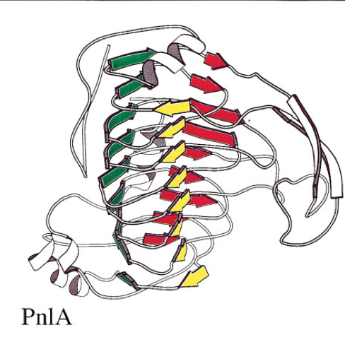[5]

*Five of the most common domains are:*

1- SH2

[6]

2- PTB

[7]

3 - SH3

[8]

4 - PDZ

[9]

5 -PH

[10]

5th questions references:

1. Jakubowski H. C4. common motifs in proteins. Biology LibreTexts. https://bio.libretexts.org/Bookshelves/Biochemistry/Book%3A_Biochemistry_Online_(Jakubowski)/02%3A_PROTEIN_STRUCTURE/2C%3A_Understanding_Protein_Conformation/C4._Common_Motifs_in_Proteins. Published March 6, 2021. Accessed March 12, 2022.
2. MH; KSH. Protein motifs. 7. the four-helix bundle: What determines a fold? FASEB journal : official publication of the Federation of American Societies for Experimental Biology. https://pubmed.ncbi.nlm.nih.gov/7649401/. Accessed March 12, 2022.
3. Bank RCSBPD. 1EI0: NMR structure of the alpha-helical hairpin of P8MTCP1. RCSB PDB. https://www.rcsb.org/structure/1ei0. Accessed March 12, 2022.
4. Zhang C, Kim S-H. A comprehensive analysis of the Greek key motifs in protein ?-barrels and ?-sandwiches. *Proteins: Structure, Function, and Genetics*. 2000;40(3):409-419. doi:10.1002/1097-0134(20000815)40:3<409::aid-prot60>3.0.co;2-6
5. Jenkins J, Mayans O, Pickersgill R. Structure and evolution of parallel β-helix proteins. *Journal of Structural Biology*. 1998;122(1-2):236-246. doi:10.1006/jsbi.1998.3985
6. Pasculescu A. Sh2 domain. The Pawson Lab - Home. http://pawsonlab.mshri.on.ca/index4fda.html?option=com_content&task=view&id=178&Itemid=64. Accessed March 12, 2022.
7. Sain N, Tiwari G, Mohanty D. Understanding the molecular basis of substrate binding specificity of PTB domains. *Scientific Reports*. 2016;6(1). doi:10.1038/srep31418
8. Pasculescu A. SH3 domain. The Pawson Lab - Home. http://pawsonlab.mshri.on.ca/indexadc5.html?option=com_content&task=view&Itemid=64&id=179. Accessed March 12, 2022.
9. Signaling C. PDZ protein domain. Cell Signaling Technology. https://www.cellsignal.com/learn-and-support/protein-domains-and-interactions/pdz-protein-domain. Accessed March 12, 2022.
10. Signaling C. Ph protein domain. Cell Signaling Technology. https://en.cellsignal.jp/learn-and-support/protein-domains-and-interactions/ph-protein-domain. Accessed March 12, 2022.